Big Data Analysis of NYC Yellow Taxi Trip Records
MIT 805: Big Data Group Project (2026) — Part 2: MapReduce & Visualization
[Vincent Mabuza - u10633244] and [Linda Masia – u21607363]

1. Processing objective: Why are you analyzing the data, what are you looking to achieve or obtain from such analysis. What is your central question?

Having generated a representatively sampled processing dataset of 3.52 GB spanning four unique licensing/vehicle types (Yellow, Green, FHV, and FHV-HV), we now aim to extract high-value operational, environmental, and socio-economic insights. Our analysis uses PySpark's parallel processing engine to perform aggregations, aligning with MapReduce logic.

Central Question
To provide clear operational and policy value, our analysis targets a central question:
When and where are demand peaks across different service types (Yellow, Green, FHV, and FHV-HV)?

2., 3,. 4. MapReduce-style implementation: Process dataset using PySpark, implementing the MapReduce paradigm.

To answer our central question: When and where are the demand peaks across different service types (Yellow, Green, app-based FHV-HV)?, we need to locate where and when demand peaks occur for all four services.
We structure our PySpark job around MapReduce concepts:
- Map (Transformation & Projection): We parse timestamps, extract the pickup hour, map files to their respective service categories, and keep only the necessary columns.
- Shuffle (Grouping): We partition and group the data across the cluster based on service type, pickup hour, and PU Location ID keys.
- Reduce (Aggregation): We count the total records per key combination.
Here is the code for the above operations:

from pyspark.sql import functions as F
# 1. Map/Load phase: Load Parquet datasets using Spark
yellow_path = "data/processing/yellow_processing.parquet"
green_path = "data/processing/green_processing.parquet"
fhv_path = "data/processing/fhv_processing.parquet"
fhvhv_path = "data/processing/fhvhv_processing.parquet"

df_yellow = spark.read.parquet(yellow_path)
df_green = spark.read.parquet(green_path)
df_fhv = spark.read.parquet(fhv_path)
df_fhvhv = spark.read.parquet(fhvhv_path)

# 2. Map-style transformations: project, extract hour, and tag service type
# Yellow Standardizations
yellow_mapped = df_yellow.select(
F.lit("Yellow").alias("service_type"),
F.hour("tpep_pickup_datetime").alias("pickup_hour"),
F.col("PULocationID").cast("integer").alias("PULocationID")
).filter("pickup_hour IS NOT NULL AND PULocationID IS NOT NULL")

# Green Standardizations
green_mapped = df_green.select(
F.lit("Green").alias("service_type"),
F.hour("lpep_pickup_datetime").alias("pickup_hour"),
F.col("PULocationID").cast("integer").alias("PULocationID")
).filter("pickup_hour IS NOT NULL AND PULocationID IS NOT NULL")

# FHV Standardizations (FHV uses pickup_datetime)
fhv_mapped = df_fhv.select(
F.lit("FHV").alias("service_type"),
F.hour("pickup_datetime").alias("pickup_hour"),
F.col("PULocationID").cast("integer").alias("PULocationID")
).filter("pickup_hour IS NOT NULL AND PULocationID IS NOT NULL")

# FHVHV Standardizations
fhvhv_mapped = df_fhvhv.select(
F.lit("FHVHV").alias("service_type"),
F.hour("request_datetime").alias("pickup_hour"),
F.col("PULocationID").cast("integer").alias("PULocationID")
).filter("pickup_hour IS NOT NULL AND PULocationID IS NOT NULL")

# Union the mapped streams together
union_mapped = yellow_mapped.union(green_mapped).union(fhv_mapped).union(fhvhv_mapped)

# 3. Shuffle & Reduce phase: Group by keys and aggregate counts
demand_peaks = union_mapped.groupby("service_type", "pickup_hour", "PULocationID") \
.agg(F.count("*").alias("trip_count")) \
.orderBy(F.desc("trip_count"))

# 4. Show execution DAG/Plan as evidence of Spark's execution model
demand_peaks.explain(True)

5. Distributed execution evidence

Traditional Hadoop MapReduce follows a strict sequence of sequential jobs: Map → Shuffle → Reduce. Every intermediate step must write state and data back to disk to ensure resilience. This introduces massive I/O serialization penalties if multiple analytical stages or joins are chained together. In contrast, Apache Spark uses a Directed Acyclic Graph (DAG) execution engine:
- Transformations (like select, filter, union, and groupby) are not executed immediately, they construct an execution plan (the DAG).
- Spark splits the DAG into stages at boundary lines where data shuffling is mandatory (such as groupby). Within a single stage, Spark lines multiple narrow transformations in memory, avoiding writing any intermediate files to disk.
- Spark optimizes the execution plan beforehand (shown above in the .explain(True) output), removing redundant projections and pushing down filters directly to the Parquet source level.

6. Results: Interpret results both technically and in terms of business value.

The demand peaks have been evaluated over all four service streams—Yellow, Green, FHV, and FHV-HV and the results are tabulated below.

 | service_type | pickup_hour | PULocationID | trip_count
0 | Yellow | 18 | 161 | 308647
1 | Yellow | 17 | 161 | 298530
2 | Yellow | 15 | 237 | 273476
3 | Yellow | 18 | 237 | 273349
4 | Yellow | 17 | 237 | 273068
5 | Yellow | 14 | 237 | 272249
6 | Yellow | 16 | 132 | 269217
7 | Yellow | 19 | 161 | 268433
8 | Yellow | 16 | 237 | 262563
9 | Yellow | 16 | 161 | 258759
10 | Yellow | 15 | 236 | 257040
11 | Yellow | 20 | 161 | 255085
12 | Yellow | 21 | 161 | 248026
13 | Yellow | 20 | 132 | 246704
14 | Yellow | 15 | 132 | 244817
15 | Yellow | 17 | 132 | 243155
16 | Yellow | 17 | 236 | 242801
17 | Yellow | 13 | 237 | 242517
18 | Yellow | 19 | 132 | 241988
19 | Yellow | 18 | 236 | 238495
The top 20 demand hotspots are entirely dominated by the yellow cab service type. These top peaks cluster around:
- Zone 161 (Midtown East): Reaching peak demand of 308,647 trips at 18:00 (6 PM) and 298,530 trips at 17:00 (5 PM).
- Zone 237 (Upper East Side South): Showing consistent high-volume demand from 13:00 to 18:00.
- Zone 132 (JFK Airport): Featuring strong late-afternoon and evening peaks (e.g., 16:00 to 20:00).
- Zone 236 (Upper East Side North): Experiencing typical rush-hour traffic in the mid-to-late afternoon.
This distribution illustrates that traditional taxi hailing (Yellow Cabs) still dictates the absolute highest volume density peaks in these localized Manhattan hubs and major airports during commuter and afternoon travel hours.

7. Visualization: Create visualizations (graphs, charts, dashboards).

To make our findings interpretable for stakeholders and business planning, we will visualize the top 20 demand hotspots using a structured bar plot showing the peak pickup hours and taxi zones.

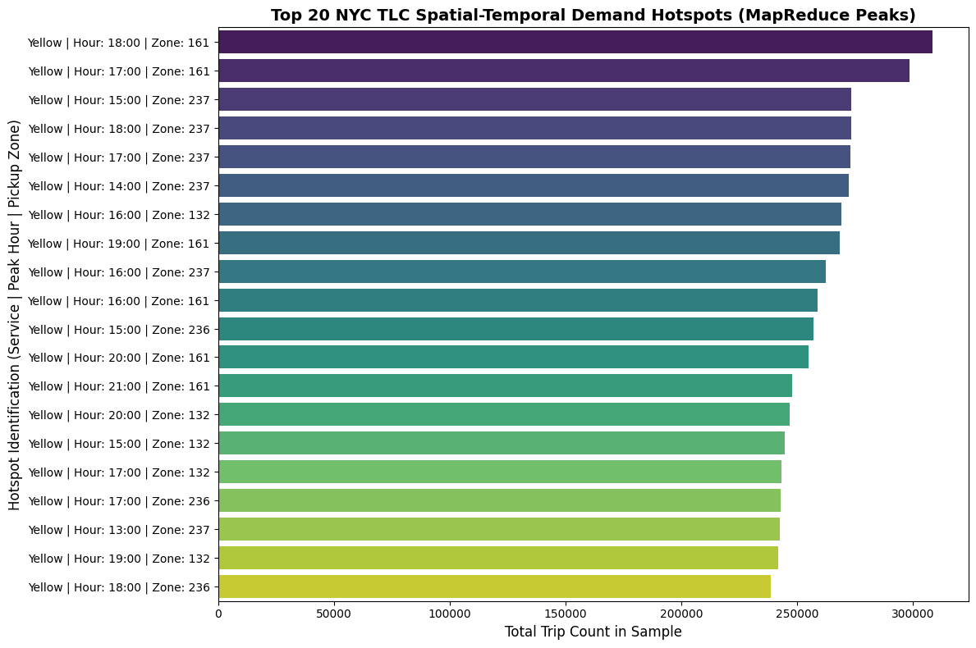
8. Business/societal interpretation

Technical Interpretation
MapReduce Paradigm: The Map-side executed parallel standardizations and projections on independent workers. The Shuffle phase partitioned records with matching key signatures (service type, pickup hour, pickup Location ID) across the cluster, and the Reduce phase efficiently aggregated counts without writing intermediate stage files to disk.

Business & Societal Value
- Fleet operators can leverage this spatial-temporal information to position vehicles. For example, during afternoon rush hours (17:00–18:00), drivers should concentrate heavily near Zone 161 (Midtown East) and Zone 237 (Upper East Side South) to capture maximum demand.
- The heavy concentration of Yellow cab trips peaking specifically around Midtown and Upper East Manhattan core zones highlights the critical need for congestion pricing policies. It validates why targeted surcharges are concentrated in Manhattan below 60th Street to mitigate severe urban gridlocks.
- Because the top peaks are completely dominated by yellow cabs in the Manhattan core, app-based FHV-HV services and green cabs play a crucial complementary role by servicing outer boroughs where yellow taxi density is low.

